Dino Jump

Custom Project Final Report

Winter 2018

Thomas Lee

Introduction

The game Dino Jump has a dinosaur on the left that is able to jump, as obstacles such as cacti move right to left on the screen towards the dinosaur, similar to the game that comes up on Google Chrome when there is no internet connection. The dinosaur is able to jump to avoid these obstacles. Jump length has also been implemented, or in other words, the dinosaur jumps one square with a singular button press, or jumps multiple squares when held. (The dinosaur will come down eventually after 4 squares have been covered, so it cannot just stay up there forever.) The game is infinite with the speed of the environment increasing as time goes by. The score increases every time the player jumps over a cactus. If the dinosaur collides with one of these obstacles, you lose.

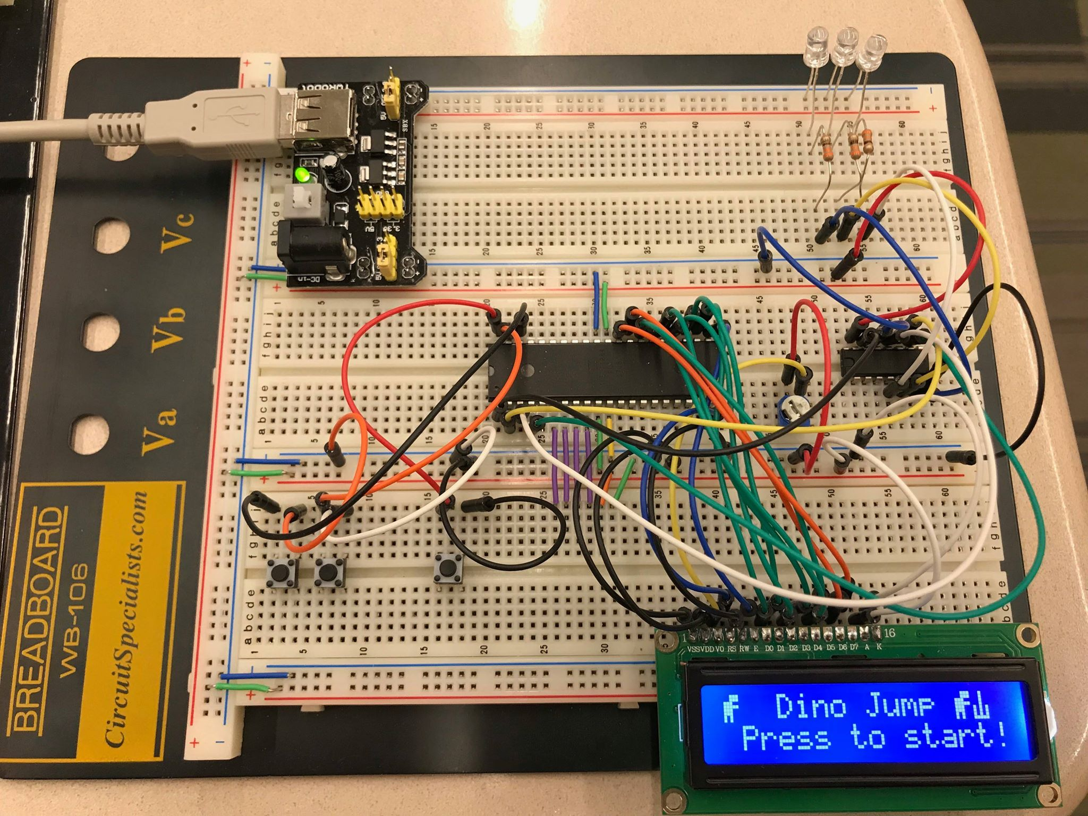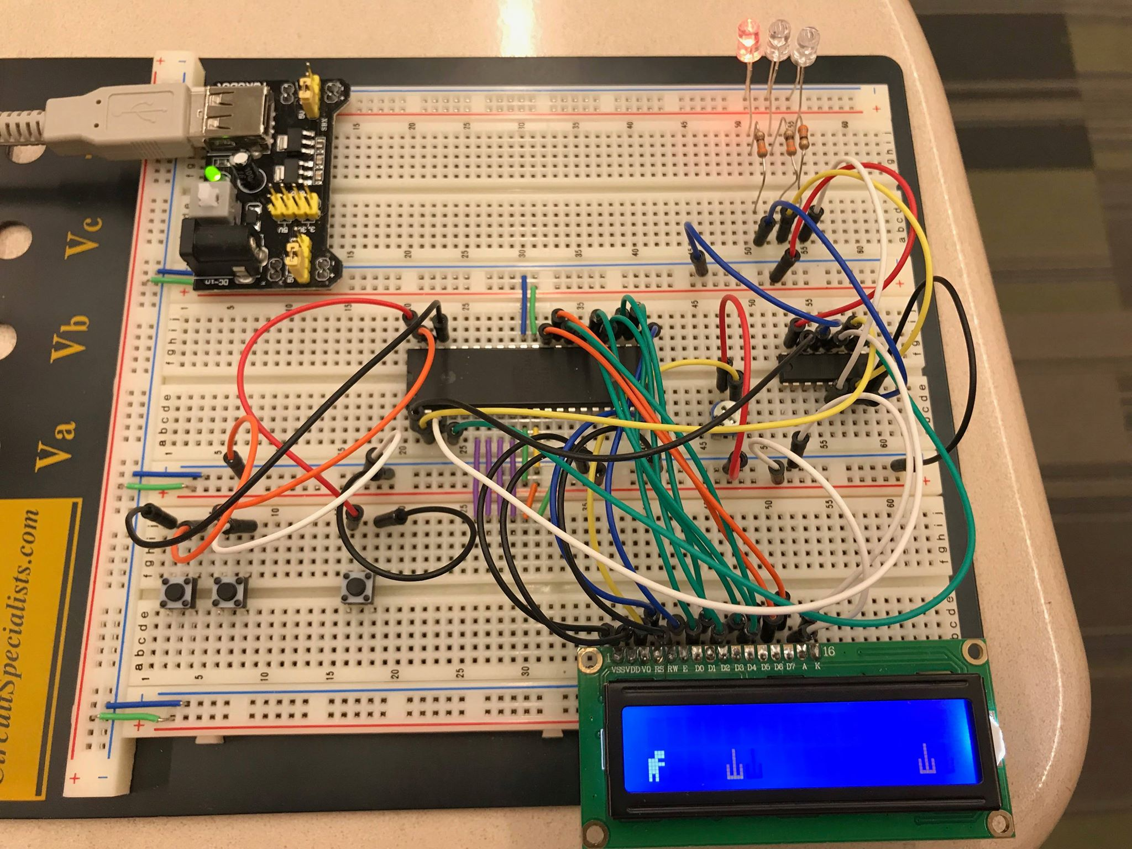

Hardware

Parts List

The hardware used to in this design is listed below. The equipment not taught in this course has been bolded.

* Atmega1284 Microcontroller
* 16x2 LCD Screen
* **Shift register**
* Buttons
* LEDs
* **SNES Controller**

Pinout



Software

I used timer.h, io.h, and io.c files, as well as code for the task scheduler and the transmit_data function for the shift register all given to us in lab. Three state machines were developed for each level of the game, with shorter periods for each state machine as the level increases. (Simulates faster cacti coming towards the player.)

Complexities

Completed Complexities:

* Creating custom characters on the LCD screen
* Using EEPROM to save high score
* Using shift register to display current level
* Game logic

Incomplete Complexities:

* Interfacing SNES controller with Atmega1284

YouTube Link

<https://www.youtube.com/watch?v=t9GCv65FF5U>

Known Bugs

* Sometimes the game is not sampling fast enough to register button presses. (The way the software is structured however, this is remedied in later levels as the faster levels use a faster timer period which allows for more accurate button press recognition.) Also see: future work
* The high score is not displayed properly over a score of 9, I believe due to EEPROM storing the score as an ASCII character value. Using arithmetic conversions to put these values into integers or some other data type should fix this.
* Sometimes when playing the game multiple times, when starting again, level 1 ends prematurely, sending players to level 2 too early. I believe this is because I do not reset my variables correctly at some point.

Shortcomings

* Obstacles are not random. The same pattern of cacti come towards the dinosaur every time, due to a lack of a better hit detection. Also see: future work
* I planned on using an SNES controller as a complexity/build upon, but after testing my controller on another student’s working SNES program, I discovered that my controller was faulty. This is why I originally suspected I needed to use the shift register, to conserve pins on the Atmega1284 since the SNES controller might have caused me to run out of pins.

Future work

The next features I would add are randomizing obstacles, which also requires revising the system for hit detection. I also plan on adding birds to the game, just as the actual Google Chrome game has, to add another level of difficulty to the game, with things to dodge on the top row of the LCD rather than only cacti on the bottom row. On top of that, I want to add coins or something for the dinosaur to collect as it goes through the levels. This would replace the current scoring system, instead of the current score increase when jumping over a cactus. The last thing I would add would be to repurpose my shift register to display a health bar, and revising the game logic to allow players to collide with 3-5 obstacles before ending the game.